Brisbane, March 12, 2026
From Munich to Sydney: Entrepreneurship Research, Community, and New Horizons at ACERE 2026
First Australian Conference Experience Full of Insights, Feedback, and New Connections
My conference season of 2026 started with a very special visit to the other side of the world: Australia. In February, I attended the ACERE 2026 conference at the University of Sydney, presenting work in progress on systems thinking practices in entrepreneurship, participating in the Doctoral Consortium, and taking part in a Paper Development Workshop (PDW). With the longest flight of my life (so far) behind me and a temperature switch from snowy Munich to the sunny east coast of New South Wales, it turned out to be an intensive and enriching week filled with many new insights and my very first impressions of Australia.
ACERE, the Australasian Consortium for Entrepreneurship Research Excellence, is a scholarly community dedicated to advancing entrepreneurship research and fostering connections among researchers across Australasia and beyond. The annual ACERE conference brings together scholars at different career stages for paper presentations, workshops, panels, and community-building activities. From the very first moment, the conference felt really friendly and supportive, like coming home to a great community. With around 200 participants, ACERE has a close-knit feel that larger conferences rarely achieve, where you quickly get to know faces, continue conversations across sessions, and never feel lost in the crowd.
The conference week started for me before the official conference start with the Doctoral Consortium, hosted by Anna Jenkins (University of Queensland) and Olga Kokshagina (University of Sydney). The morning opened with two inspiring keynotes. Michael Lounsbury (University of Alberta) kicked things off with a broad exploration of what organization theory is, diving into ontological differences in contemporary organization theory and presenting a typology developed in joint work with Joel Gehman (George Washington University). He also shared his thoughts on how to incorporate theoretical tensions in papers and reflected on our identity as researchers, which encouraged us to think about who we are as a scholar and to follow what excites us and gives us passion. Dean Shepherd (University of Notre Dame) then took us further into the world of theorizing by sharing his thoughts on how to start thinking about theorizing, how he builds stories and writes his own papers, and offering different ramblings about “re”-search, “me”-search, and “we”-search, a framing that often came up again throughout the week. It was a session that sent us back to the basics in the best possible way, guided by the words of Karl Weick (1989: 516) that “theory cannot be improved until we improve the theorizing process and we cannot improve the theorizing process until we describe it more explicitly, operate more self-consciously, and decouple it from validation more deliberately”. The keynotes were followed by mentoring sessions with senior faculty, a PDW with structured feedback on our submitted Doctoral Consortium papers, and a panel discussion with senior scholars including Dean Shepherd, Erkko Autio, Kim Klyver, Martie-Louise Verreynne, Michael Lounsbury, Mile Terziovski, and Sarah Cooper, covering the topic of impactful entrepreneurship research amid disruptive times. The day also featured presentations by journal editors, who shared practical insights into the publication landscape. The Doctoral Consortium concluded with a group dinner that provided further opportunity for informal exchange among participants and senior scholars with classic Australian seafood.
The main conference began on the second day with a morning keynote by Erkko Autio (Imperial College London) on whether and how entrepreneurship research should embrace a design science approach, followed by a full day of paper presentations and an evening dinner at a stunning location in Sydney with a breathtaking view of the Sydney Harbour Bridge and the Opera House, which provided the perfect backdrop for continued conversations and new connections.
On the third day, the morning started with a keynote by Michael Lounsbury on broadening the scope of entrepreneurship research with all participants in the main auditorium. Afterwards, I had the opportunity to serve as session chair in the track on entrepreneurship education. In the afternoon, I presented joint work in progress with my co-author Jonah Zankl (University of Queensland) on systems thinking practices of entrepreneurs in the entrepreneurial thinking track. The presentation generated great interest, led to valuable discussions about methodological and theoretical aspects of our work, and left me with a notebook full of ideas to continue working on. The evening concluded with the conference dinner at the historic Queen Victoria Building in Sydney, which was a truly special setting for a memorable conference night.
On the fourth and final day, interactive roundtable paper sessions allowed for even more in-depth engagement with individual papers and their authors before the closing panel brought the main conference to a thoughtful ending. In the afternoon, the Doctoral Consortium reconvened for its final sessions, covering the topics of navigating the job market, with career conversations with Samira Nazar, Jonah Zankl, Mehrzad Saeedikiya, and Jarryd Daymond, writing and communicating for impact, and a collective reflection on the conference and lessons learned. This wrap-up in a safe space with lots of personal experiences and the group building exercises of walking outside and exploring the campus of the University of Sydney were a wonderful way to consolidate the insights of the week and to think ahead. A highlight of the Doctoral Consortium was the dynamic and supportive energy in the room. I have attended multiple doctoral consortia in the past, but must confess that with an almost all-female cohort, it was a particularly memorable and inspiring atmosphere.
Throughout the week, the many conversations with fellow researchers, both new and familiar faces, during sessions, coffee breaks, and social events led to new ideas and valuable insights into future research directions. Participating in the ACERE 2026 conference in Sydney was a fantastic experience due to the combination of intensive research exchange, enriching doctoral sessions, and many networking opportunities in beautiful Australian surroundings. I am very grateful for the financial support provided by LMU Management Alumni, which made this journey possible. Looking at this conference experience in hindsight while writing this article, I am very grateful for the thoughtful feedback on our work, the deep conversations, new insights, and all the people who make this academic journey meaningful. Sydney, it was a pleasure, and something tells me it will not be the last time.
Impressions:
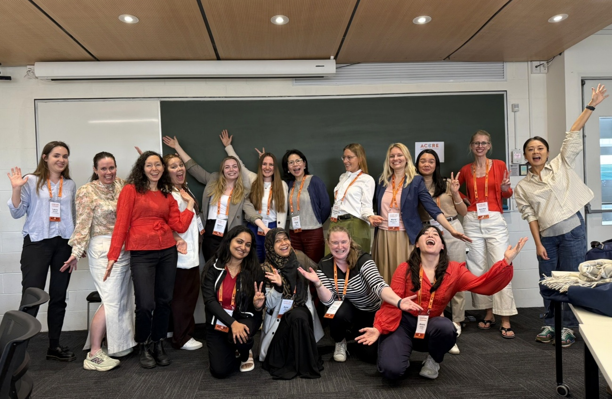
Participants of the Doctoral Consortium at ACERE 2026 in Sydney, with an almost all-female cohort bringing a particularly dynamic and supportive energy to the final day.
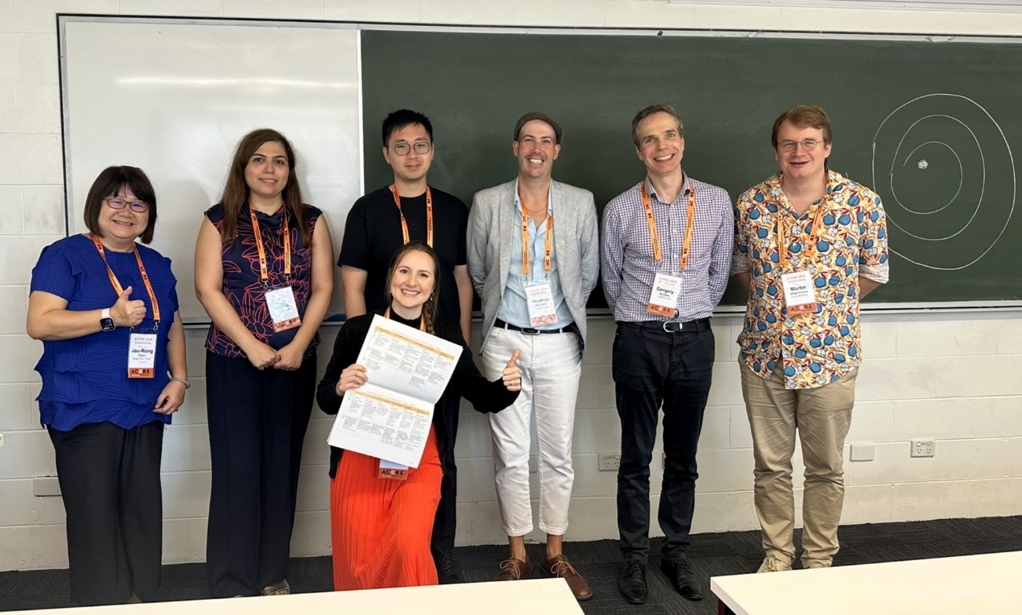
Serving as session chair in the entrepreneurship education track at ACERE 2026, together with all presenters of the session.
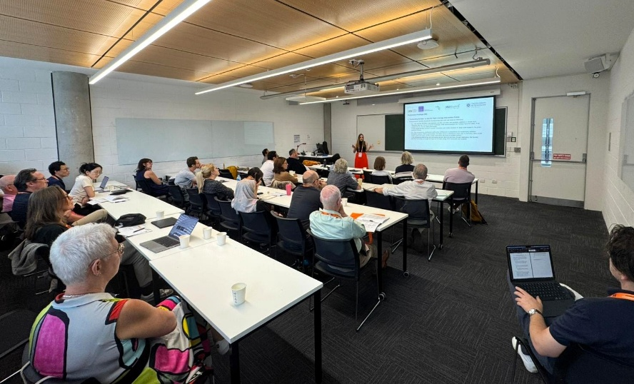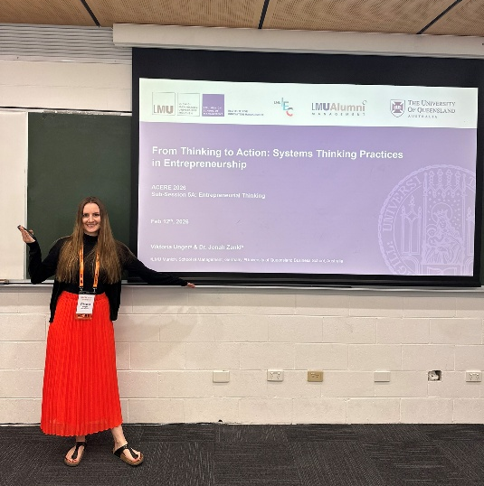
Presenting joint work in progress with co-author Jonah Zankl (University of Queensland) on systems thinking practices of entrepreneurs in the entrepreneurial thinking track at ACERE 2026.
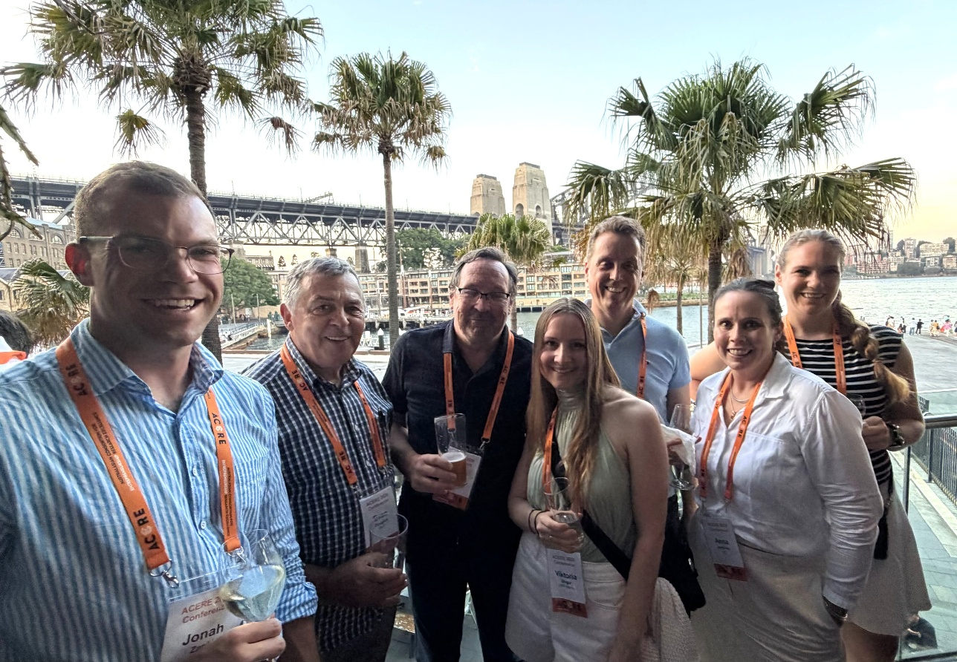
With entrepreneurship research colleagues at a conference social event with views of the Sydney Harbour Bridge and the Opera House during ACERE 2026 (from left to right: Jonah Zankl, Evan Douglas, Dean Shepherd, Viktoria Unger, Henri Burgers, Anna Jenkins, and Janine Crivelli).

