Master’s Thesis
My Super Fancy
Thesis Title
Munich School of Management
Ludwig-Maximilians-University Munich
Max Mustermann
Musterstraße 1, 80000 München
Matriculation No. XXXXXXXX
Munich, 1st of January 2023
A Thesis Submitted in Partial Fulfillment of the Requirements for the Degree of
Master of Science in Business Administration
Referee: Prof. Dr. Andreas Richter

List of Contents
List of Contents - 2 -
List of Appendices - 3 -
List of Figures - 4 -
List of Tables - 5 -
List of Abbreviations - 6 -
List of Symbols - 7 -
1 Introduction - 8 -
2 This is a Section Title - 9 -
2.1 This is a subsection title - 9 -
2.2 Figures and tables - 9 -
2.2.1 Figure Example - 9 -
2.2.2 Table Example - 9 -
2.3 Mathematical formulas - 10 -
Appendices - 11 -
References - 13 -

List of Appendices

Appendix 1: This is an appendix - 11 -
Appendix 2: Correlation matrix - 12 -

List of Figures

Figure 1: This is a figure - 9 -

List of Tables

Table 1: This is a table - 9 -

List of Abbreviations

COVID-19 | Coronavirus disease 2019
OLS | Ordinary least-squared

List of Symbols
p | probability
u | utility

Introduction
A thesis presented on the history of astronomy and the solar system, beginning with the birth of the solar system, and covering the geology, atmosphere, and moons of Mercury, Venus, Earth, Mars, Jupiter, Saturn, and Uranus.
To change the spacing between, for example, body text paragraphs, click on a paragraph and then click Paragraph on the Format menu. On the Indents and Spacing tab, under Spacing, reduce the number in the After list, and make additional adjustments as needed.
To save your style changes, with the cursor blinking in the changed paragraph, click Styles and Formatting on the Formatting menu. In the Styles and Formatting pane, right-click the selected style and choose Update to Match Selection.

This is a Section Title

This is a subsection title

Figures and tables

Figure example
On the Insert menu, point to Picture, and then click the command corresponding to the type of element you want to insert.
To insert a caption, in a new paragraph, on the Format menu, click Styles and Formatting. In the Styles and Formatting task pane, click All styles in the Show list, and then make the selection you want in the list.
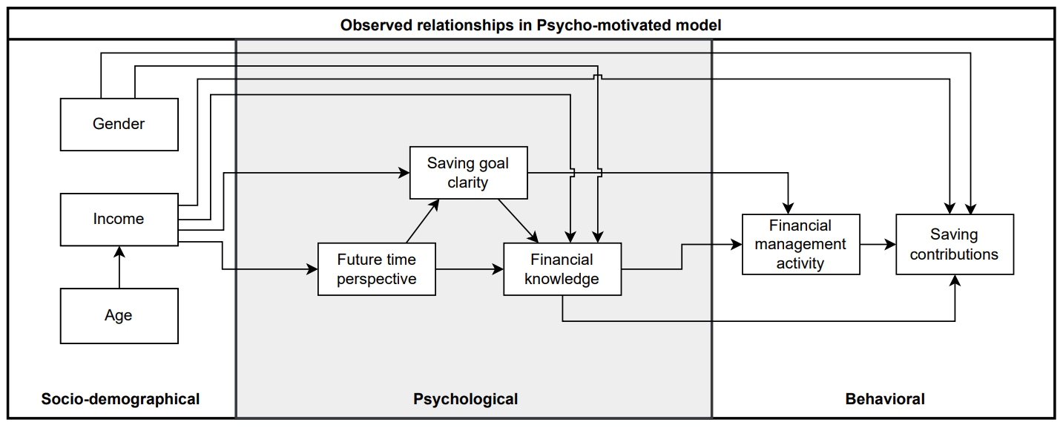
Figure 1: This is a figure

Table example
Table 1: This is a table

Mathematical formulas
$$A=πr^{2}$$ | (1)
$$a^{2}+b^{2}=c^{2}$$ | (2)
$$\dot{x_{i}}=Ax_{i}$$ | (3)
$$c_{i}=\sum_{j=1}^{N}{a_{ij}\left(x_{i}-x_{j}\right)}$$ | (4)
$$J\left(K\right)≔\int_{0}^{∞}{\left[X_{K}^{⊤}\left(t\right)\right]dt}.$$ | (5)
$$A=\left(\begin{matrix}0 & 0 & -0.01 \\ 0 & 0 & 2 \\ 1 & 0 & -0.15\end{matrix}\right)$$ | (6)

Appendices
Appendix 1: This is an appendix

Appendix 2: Correlation matrix | 15
 | 14
 | 13
 | 12
 | 11
 | 10
 | 9
 | 8
 | 7
 | 6
 | 5
 | 4
 | 3
 | 2
 | 1
 | Variables
 |  | 1 | 2 | 3 | 4 | 5 | 6 | 7 | 8 | 9 | 10 | 11 | 12 | 13 | 14 | 15

References
Ando, A. and Modigliani, F. (1963) ‘The “Life Cycle” Hypothesis of Saving: Aggregate Implications and Tests’, The American Economic Review, 53(1), pp. 55–84.

[Harvard System of Referencing Guide:
https://library.aru.ac.uk/referencing/files/Harvard_referencing_201920.pdf]

[This page will be replaced by CV]

Ehrenwörtliche Erklärung
Ich erkläre hiermit ehrenwörtlich, dass ich die vorliegende Arbeit selbständig angefertigt habe; die aus fremden Quellen direkt oder indirekt übernommenen Gedanken sind als solche kenntlich gemacht.
Die Arbeit wurde bisher keiner anderen Prüfungsbehörde vorgelegt und auch noch nicht veröffentlicht.

München, den
(Unterschrift)

Own illustration based on Max Musterautor (2000).
Own calculation.

