Seminar Paper
My Super Fancy
Seminar Paper Title
Munich School of Management
Ludwig-Maximilians-University Munich
Max Mustermann
Musterstraße 1, 80000 München
Matriculation No. XXXXXXXX
Munich, 1st of January 2023

A Seminar Paper Submitted at the Institute for Risk Management and Insurance
(Pro-)Seminar: XXXXXXX
Winter Term 2022/2023
Supervisor: XXX

List of Contents
List of Contents - 2 -
List of Appendices - 3 -
List of Figures - 4 -
List of Tables - 5 -
List of Abbreviations - 6 -
List of Symbols - 7 -
1 Introduction - 8 -
2 Figures, tables, and mathematical formulas - 9 -
2.1 Figure example - 9 -
2.2 Table example - 9 -
2.3 Mathematical formulas - 10 -
Appendices - 11 -
References - 13 -

List of Appendices

Appendix 1: This is an appendix - 11 -
Appendix 2: Correlation matrix - 12 -

List of Figures

Figure 1: This is a figure - 9 -

List of Tables

Table 1: This is a table - 9 -

List of Abbreviations

COVID-19 | Coronavirus disease 2019
OLS | Ordinary least-squared

List of Symbols

p | probability
u | utility

Introduction
A thesis presented on the history of astronomy and the solar system, beginning with the birth of the solar system, and covering the geology, atmosphere, and moons of Mercury, Venus, Earth, Mars, Jupiter, Saturn, and Uranus.
To change the spacing between, for example, body text paragraphs, click on a paragraph and then click Paragraph on the Format menu. On the Indents and Spacing tab, under Spacing, reduce the number in the After list, and make additional adjustments as needed.
To save your style changes, with the cursor blinking in the changed paragraph, click Styles and Formatting on the Formatting menu. In the Styles and Formatting pane, right-click the selected style and choose Update to Match Selection.

Figures, tables, and mathematical formulas

Figure example
On the Insert menu, point to Picture, and then click the command corresponding to the type of element you want to insert.
To insert a caption, in a new paragraph, on the Format menu, click Styles and Formatting. In the Styles and Formatting task pane, click All styles in the Show list, and then make the selection you want in the list.
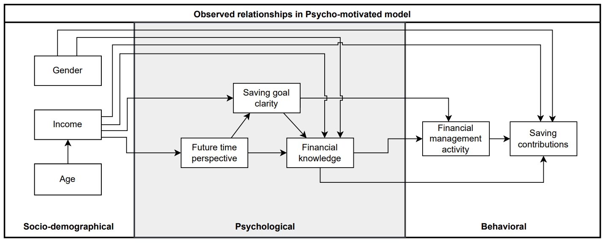
Figure 1: This is a figure

Table example
Table 1: This is a table

Mathematical formulas
$$A=πr^{2}$$ | (1)
$$a^{2}+b^{2}=c^{2}$$ | (2)
$$\dot{x_{i}}=Ax_{i}$$ | (3)
$$c_{i}=\sum_{j=1}^{N}{a_{ij}\left(x_{i}-x_{j}\right)}$$ | (4)
$$J\left(K\right)≔\int_{0}^{∞}{\left[X_{K}^{⊤}\left(t\right)\right]dt}.$$ | (5)
$$A=\left(\begin{matrix}0 & 0 & -0.01 \\ 0 & 0 & 2 \\ 1 & 0 & -0.15\end{matrix}\right)$$ | (6)

Appendices
Appendix 1: This is an appendix

Appendix 2: Correlation matrix | 15
 | 14
 | 13
 | 12
 | 11
 | 10
 | 9
 | 8
 | 7
 | 6
 | 5
 | 4
 | 3
 | 2
 | 1
 | Variables
 |  | 1 | 2 | 3 | 4 | 5 | 6 | 7 | 8 | 9 | 10 | 11 | 12 | 13 | 14 | 15

References
Ando, A. and Modigliani, F. (1963) ‘The “Life Cycle” Hypothesis of Saving: Aggregate Implications and Tests’, The American Economic Review, 53(1), pp. 55–84.

[Harvard System of Referencing Guide:
https://library.aru.ac.uk/referencing/files/Harvard_referencing_201920.pdf]

Own illustration based on Max Musterautor (2000).
Own calculation.

