Seminar Paper
My Super Fancy
Seminar Paper Title
Munich School of Management
Ludwig-Maximilians-Universität München
Maxi Musterperson
Musterstraße 1, 80000 München
Matriculation No. XXXXXXXX
Munich, 1st of January 2025

A Seminar Paper Submitted at the Institute for Risk Management and Insurance
(Pro-)Seminar: XXXXXXX
Winter/Summer Term 20XX/20XX
Supervisor: XXX

Bachelor’s/Master’s Thesis
My Super Fancy
Thesis Title
Munich School of Management
Ludwig-Maximilians-Universität München

Maxi Musterperson
Musterstraße 1, 80000 München
Matriculation No. XXXXXXXX
Munich, 1st of January 2025

A Thesis Submitted in Partial Fulfillment of the Requirements for the Degree of
Bachelor of Science in Business Administration / Master of Science in Business Administration
Referee: Prof. Dr. Andreas Richter

List of Contents
List of Contents - 3 -
List of Appendices - 4 -
List of Figures - 5 -
List of Tables - 6 -
List of Abbreviations - 7 -
List of Symbols - 8 -
1 Introduction - 9 -
2 Figures, Tables, and Mathematical Formulas - 9 -
2.1 Figure Example - 9 -
2.2 Table Example - 10 -
2.3 Mathematical Formulas - 10 -
Appendices - 12 -
References - 14 -

You can automatically generate the table of contents under the References tab. It will use any chapter headings you have explicitly formatted as such.

List of Appendices

Appendix A: This is an Appendix - 12 -
Appendix B: Correlation Matrix - 13 -

The lists of appendices, figures and tables can be generated automatically under Captions within the References tab. No need to edit them manually.

List of Figures

Figure 1: Title of the Figure - 9 -

List of Tables

Table 1: Title of the Table - 10 -

List of Abbreviations

COVID-19 | Coronavirus disease 2019
OLS | Ordinary least-squared

List of Symbols

p | probability
u | utility

Introduction
To turn a heading into a chapter that is automatically included in the table of contents, click Styles under the header Home and choose which level of header you would like it to be. Here, you can also change the styles as you please, as long they are within the formal requirements laid out by the institute.

Figures, Tables, and Mathematical Formulas

Figure Example
To include a figure, select the Insert menu, point to Picture, and then click the command corresponding to the type of element you want to insert. Make sure to mention and explain each figure/table in your text.
To insert a caption, click on References tab, and under Captions you will be able to insert a caption.
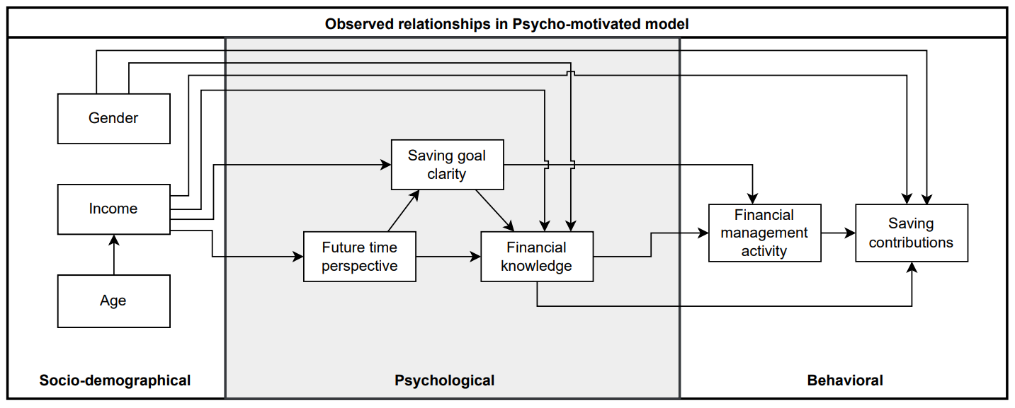
Figure 1: Caption/Title of the Figure
Note: This is where you include a brief figure description. The figure and its accompanying note should clearly explain what the figure shows, allowing the reader to understand it without reading the entire chapter.

Table Example

This is a heading | This is also a heading
This is table content | This is table content
This is table content | This is table content

Table 1: Title of the Table
Note: This is where you include a brief table description. The table and its accompanying note should clearly explain what the figure shows, allowing the reader to understand it without reading the entire chapter.

Mathematical Formulas

$$A=πr^{2}$$ | (1)
$$a^{2}+b^{2}=c^{2}$$ | (2)
$$\dot{x_{i}}=Ax_{i}$$ | (3)
$$c_{i}=\sum_{j=1}^{N}{a_{ij}\left(x_{i}-x_{j}\right)}$$ | (4)
$$J\left(K\right)≔\int_{0}^{∞}{\left[X_{K}^{⊤}\left(t\right)\right]dt}.$$ | (5)
$$A=\left(\begin{matrix}0 & 0 & -0.01 \\ 0 & 0 & 2 \\ 1 & 0 & -0.15\end{matrix}\right)$$ | (6)

Appendices
Appendix A: This is an Appendix

Appendix B: Correlation Matrix | 15
Appendix B: Correlation Matrix | 14
Appendix B: Correlation Matrix | 13
Appendix B: Correlation Matrix | 12
Appendix B: Correlation Matrix | 11
Appendix B: Correlation Matrix | 10
Appendix B: Correlation Matrix | 9
Appendix B: Correlation Matrix | 8
Appendix B: Correlation Matrix | 7
Appendix B: Correlation Matrix | 6
Appendix B: Correlation Matrix | 5
Appendix B: Correlation Matrix | 4
Appendix B: Correlation Matrix | 3
Appendix B: Correlation Matrix | 2
Appendix B: Correlation Matrix | 1
Appendix B: Correlation Matrix | Variables
Appendix B: Correlation Matrix |  | 1 | 2 | 3 | 4 | 5 | 6 | 7 | 8 | 9 | 10 | 11 | 12 | 13 | 14 | 15

References
Pears, R. and Shields, G. (2019) Cite them right: The essential referencing guide. 11th edn. London: MacMillan.
Thagard, P. (1990) ‘Philosophy and machine learning’, Canadian Journal of Philosophy, 20(2), pp. 261–276.
Include all sources of your paper using Harvard or APA referencing style in alphabetical order (tip: a referencing software will do this for you automatically). Each source should be indented after the first line, as shown by the examples.

Own illustration based on Sam Sample author (2000).
Own calculation.

