You are cordially invited to the

INVITATION

**Graduation Ceremony**

**2022 November, 24** at **4.30 p.m.**

“Friedrich von Gärtner Saal” in the   
“St. Vinzenz Haus“ at the LMU Klinikum

Guest admission begins at 4.15 p.m.

The official part with speeches and the handover of certificates will probably take 1,5 hours. Afterwards there will be a champagne reception.

**Registration requested until November, 9:**

youremail@example.com, +49 xxxxxx

The **use of public transportation** (e.g. U-Bahn Goetheplatz or U-Bahn Sendlinger Tor) is recommended, as there is limited parking on the clinic area.

The venue, a former church, can be reached only on foot via two options:

* Use the passage at **Goethestraße 69** and follow the way until you see the church-like-building on your left. Walk through the passage to your left (before the main building) and then along the side of the building with parking spaces until you reach the venue.
* Use the passage on **Nußbaumstraße 5** between “Portalklinik” and “Klinik und Poliklinik für Psychiatrie”, follow the path to the “St. Vinzenz Haus” and walk past the main entrance; then through the passage on your right; walk along the side of the building with parking spaces until you reach the venue.

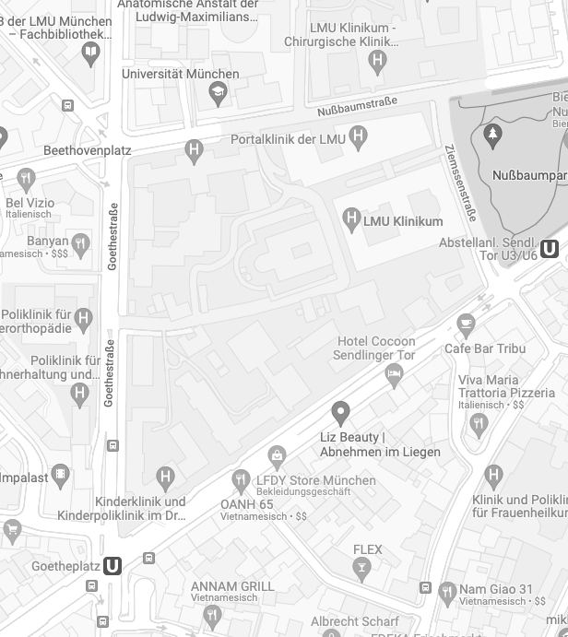

Klinik und Poliklinik für Psychatrie

St. Vinzenz Haus

